CLOUD COMPUTING
LAB 09



Submitted To:
Engr. Shoaib

Submitted By:
Komal Kashif
BSE V-A
2023-BSE-031

Task 1 — GitHub CLI, Codespace setup and authentication
- (Local desktop) Install GitHub CLI: winget install --id GitHub.cli
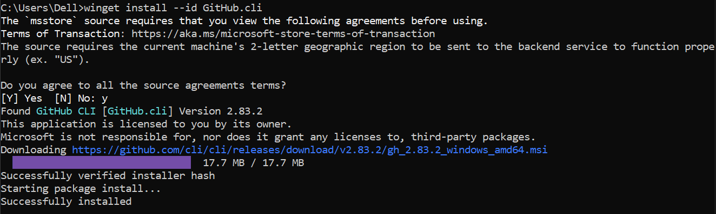
- Authenticate GH CLI for Codespaces: gh auth login -s codespace
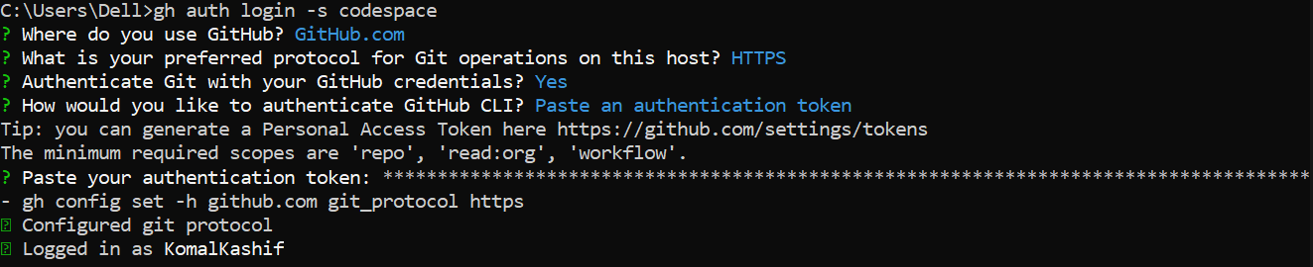
- List available Codespaces: gh codespace list

Task 2 — Install AWS CLI inside the Codespace and configure it
- Download and install AWS CLI:
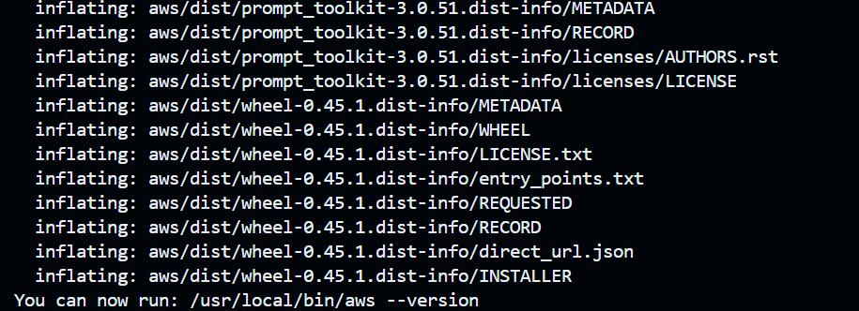
- Verify installation:
- Configure the AWS CLI (you will provide Access Key ID and Secret Access Key for a user with permissions, or use root/IAM user you prepared for the lab):
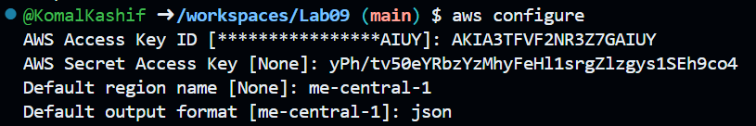
- Verify credentials/config files:
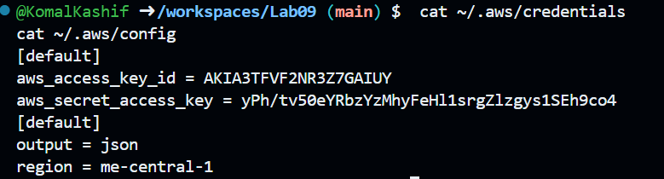
- Verify connectivity
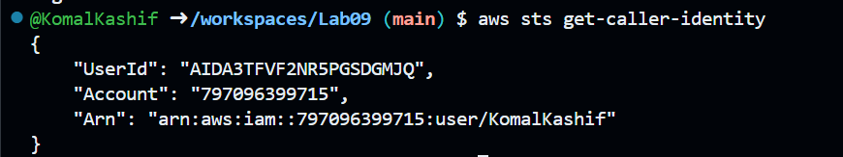

Task 3 — Create security group and add ingress rules using Codespace IP
- Create a security group
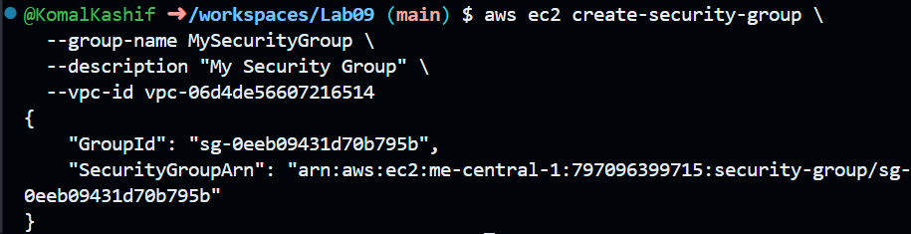
- Inspect the security group
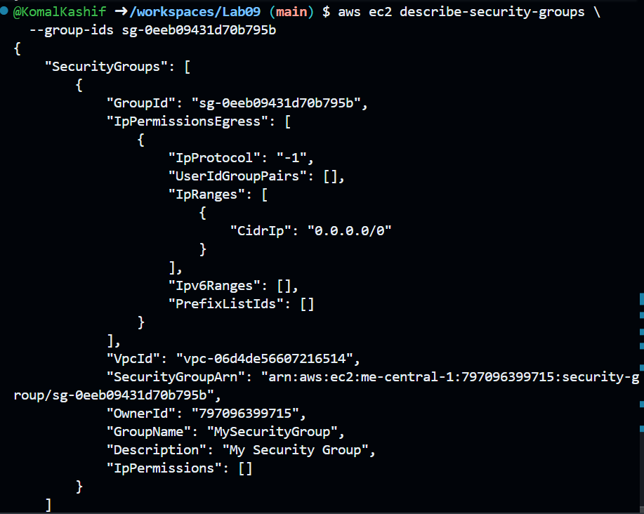
- Get your Codespace public IP
- Authorize SSH inbound on port 22 from your Codespace IP:
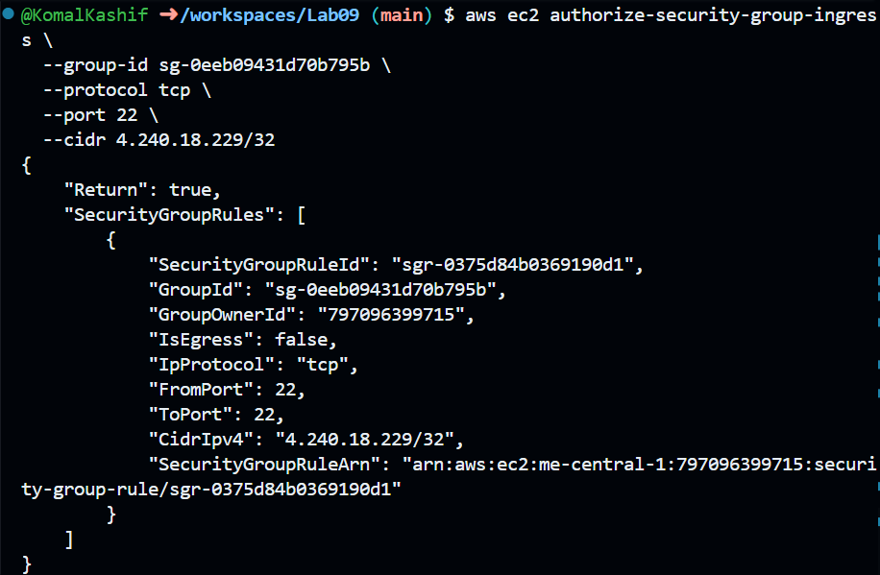
- Add an HTTP rule (port 80) using ip-permissions JSON:
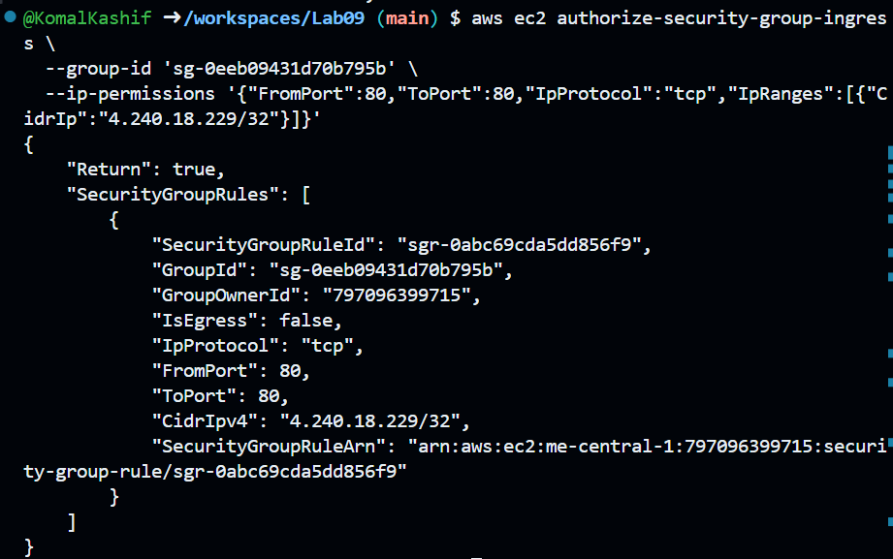

- Verify both ingress rules are present:
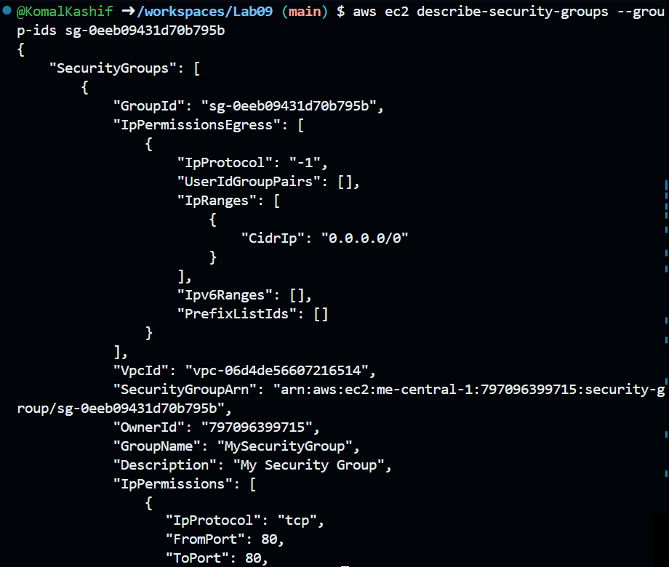
Task 4 — Create a key pair, describe key pairs, and launch EC2 instance
- Create the key pair and save the PEM file into the Codespace workspace:
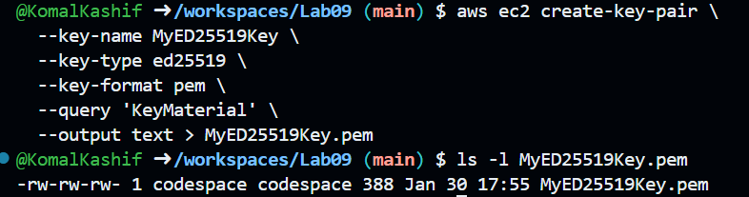
- View created key pairs:
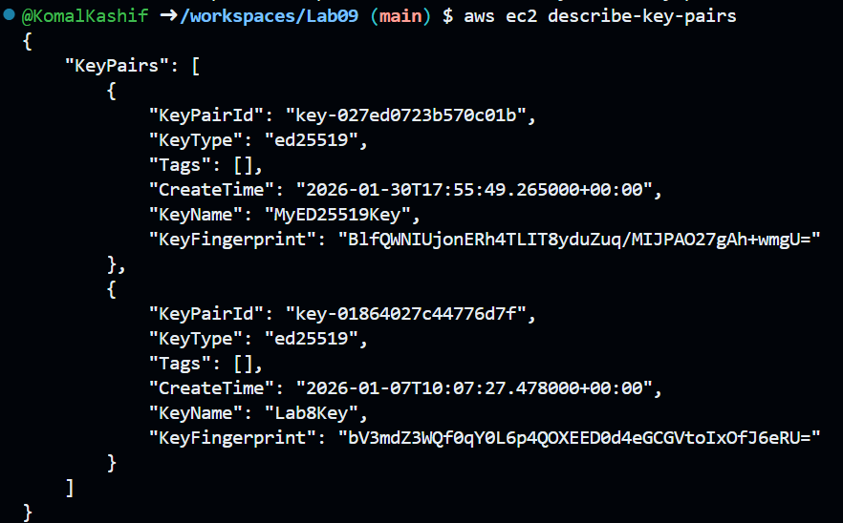

- Delete key pair:
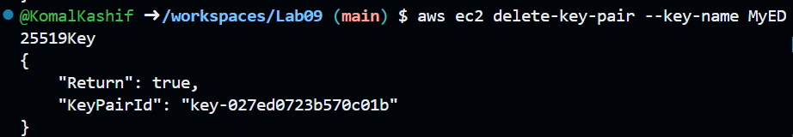
- Launch an EC2 instance
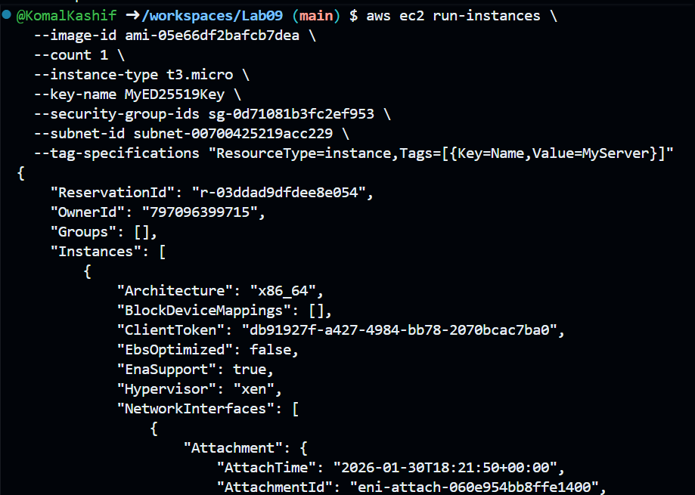
- Get the public IP address of your instance:
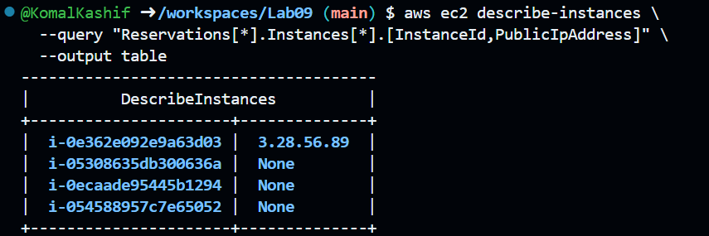

Task 5 — Understand AWS describe-* commands
- aws ec2 describe-security-groups
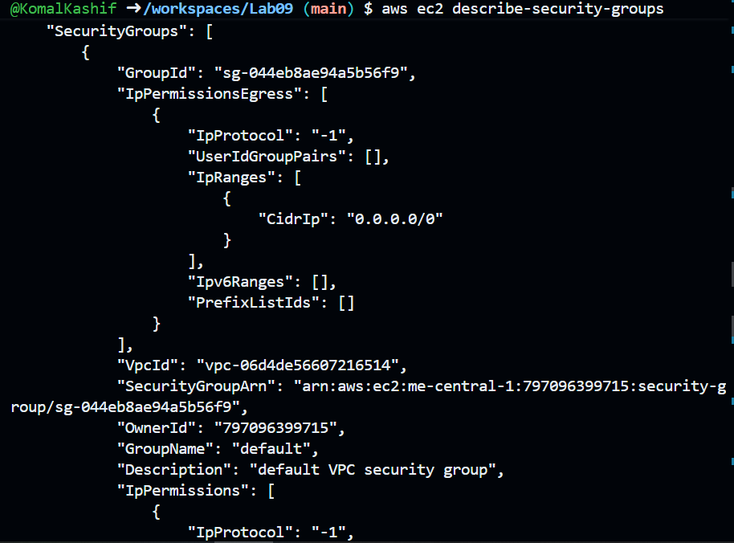
- aws ec2 describe-vpcs
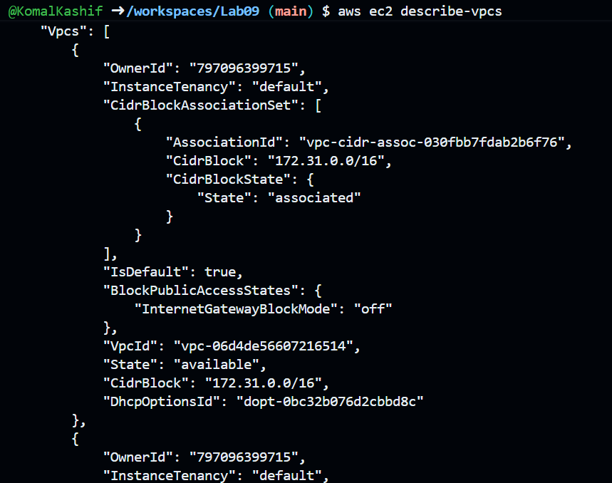

- aws ec2 describe-subnets
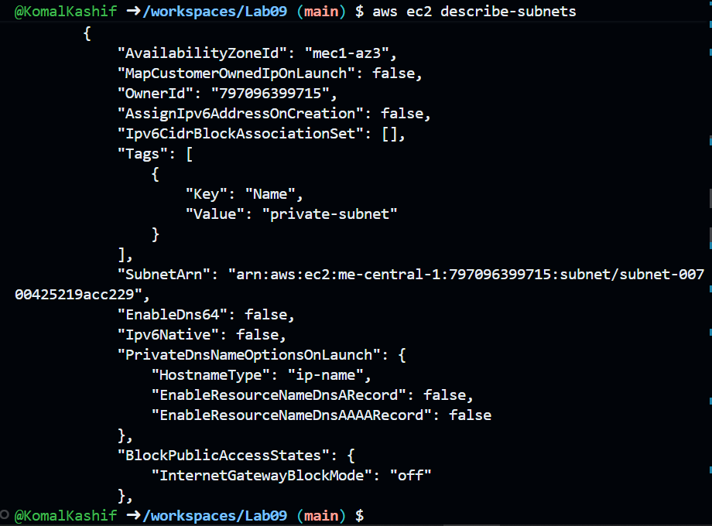
- aws ec2 describe-instances
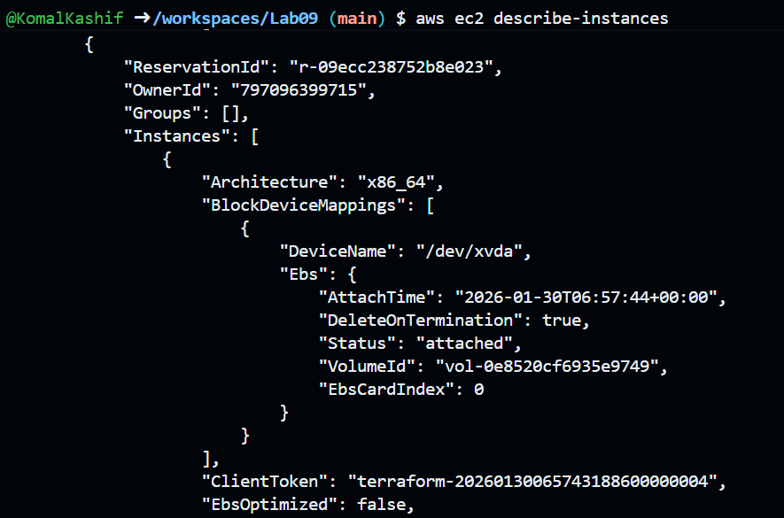

- aws ec2 describe-regions
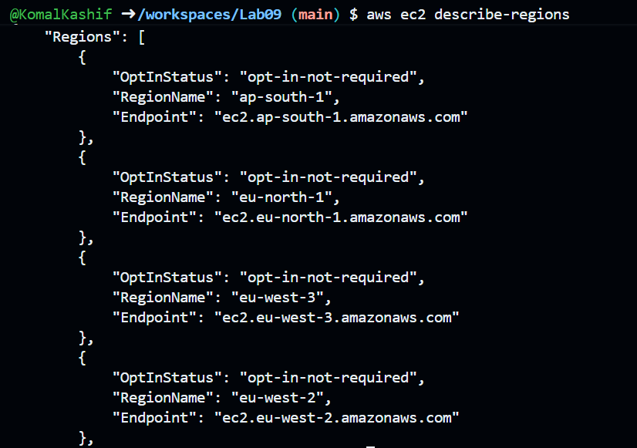
- aws ec2 describe-availability-zones
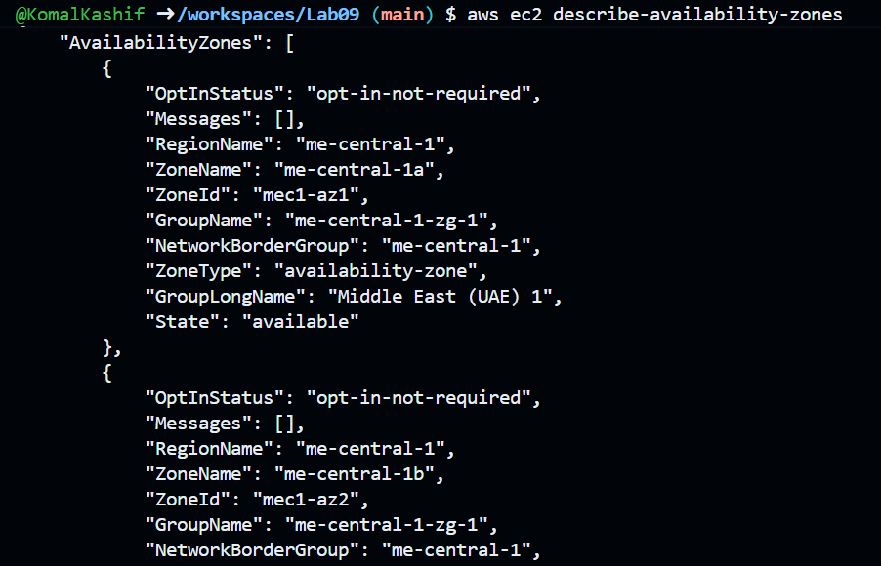
Task 6 — IAM: create group, user, attach policies, create console login & keys
- Create group:
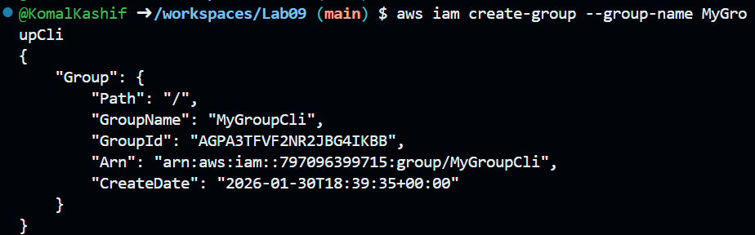

- Get group details:
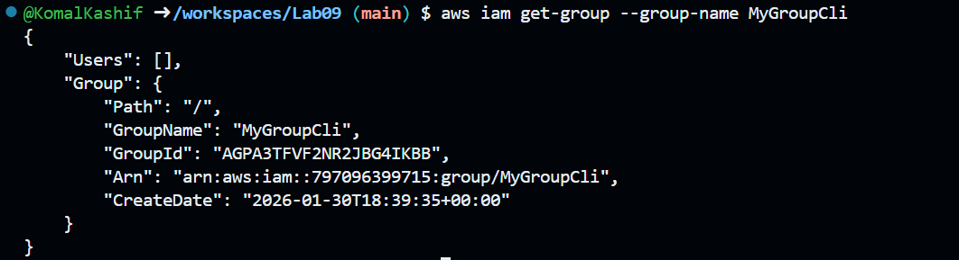
- Create user:
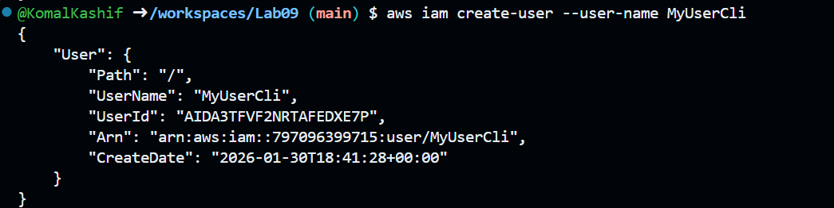
- Get user details:
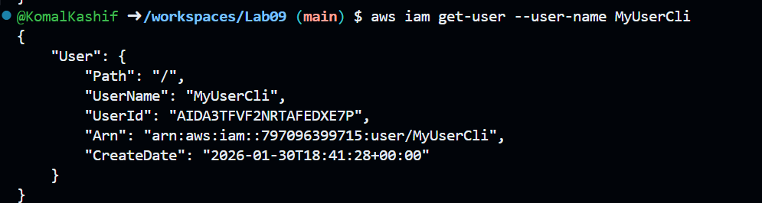
- Add user to group:
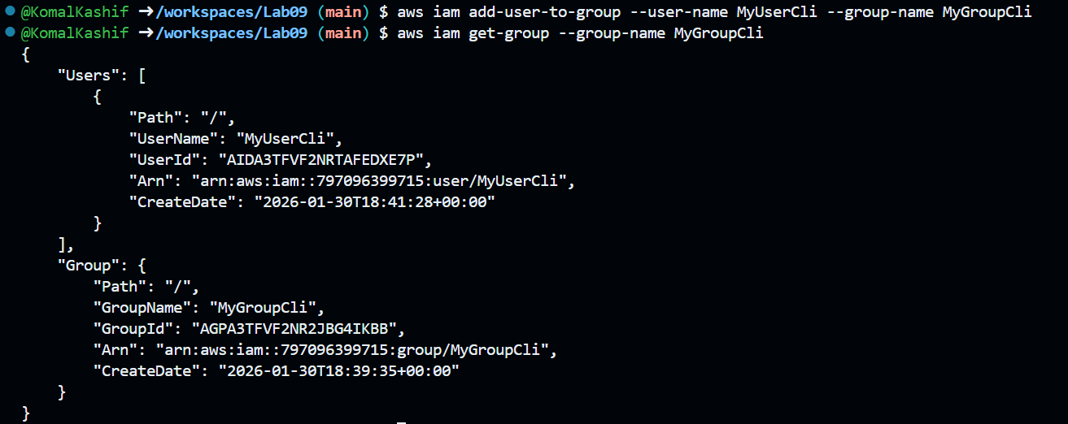

- List policies that mention EC2:
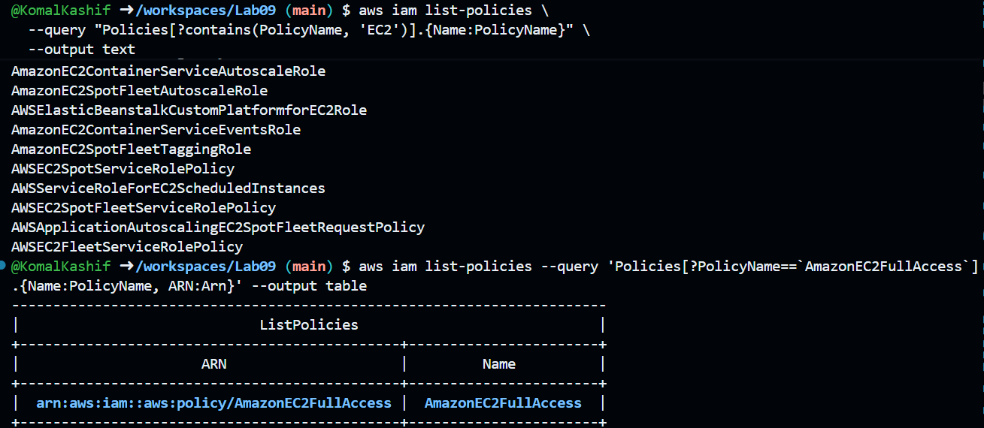
- Create a console login profile for the user:
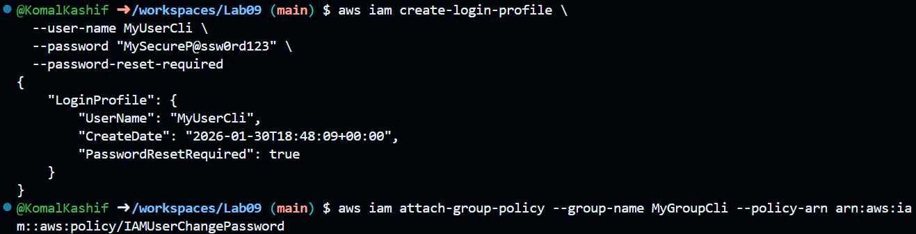
- Create access keys for the user (save AccessKeyId and SecretAccessKey securely). List access keys:
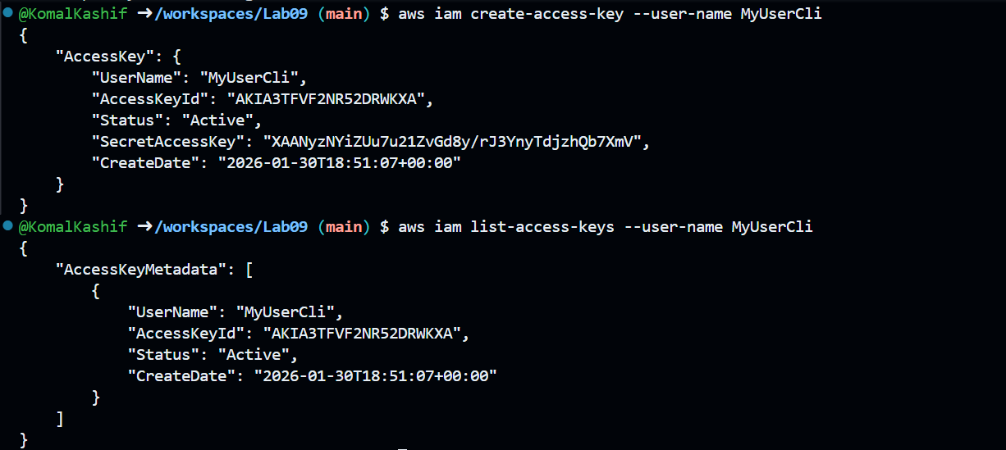
- Use environment variables to authenticate as that user in the Codespace:
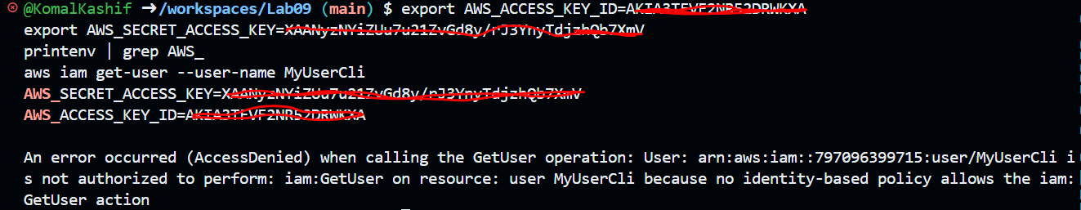
Task 7 — Filters: query with filters to find instances and their attributes
- Filter by instance
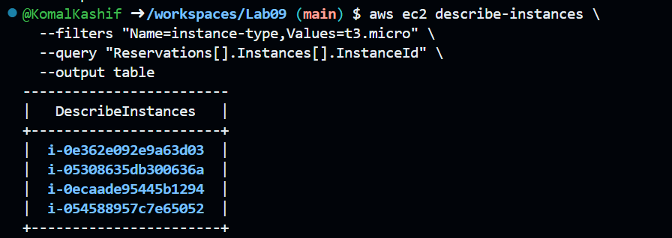
- Filter by subnet
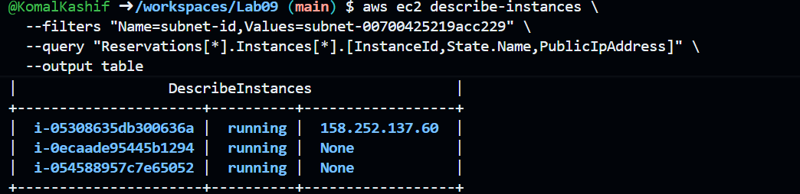
- Filter by vpc
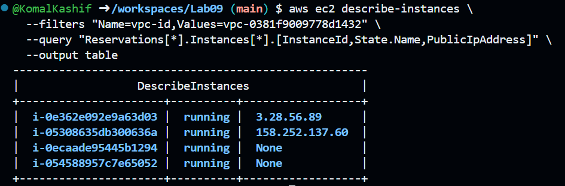

Task 8 — Use --query to format outputs for reporting
- Query table instances name
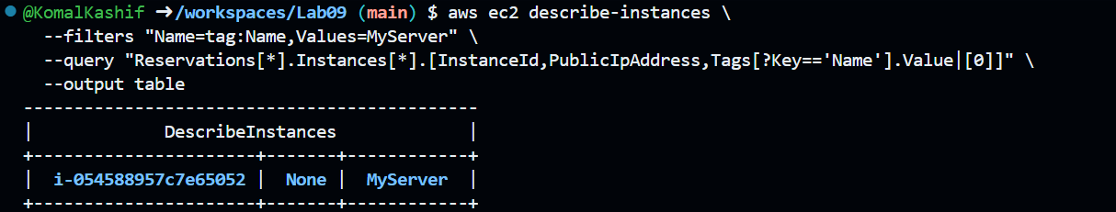
- Query table instances state
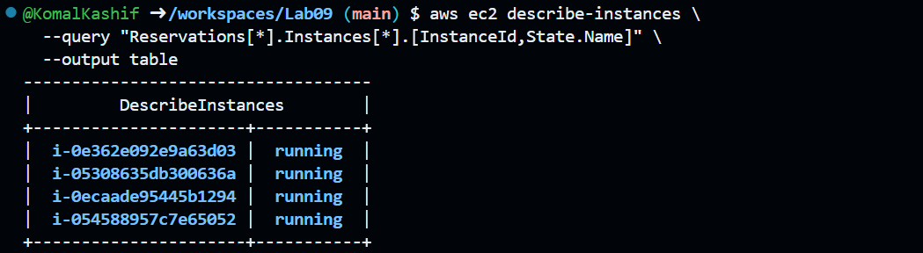
- Query table instances type
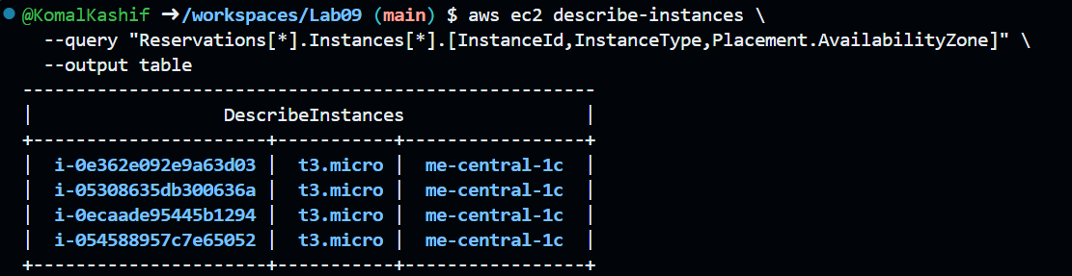
Clean-up:
